Exercise 1

Compute the following definite integrals, and specify for each if it a proper or improper integral.

Solution

It is a proper integral. Use the table of integrals.

**Answer:** .

It is a improper integral in point x=0, because the denominator cannot be equal to zero.

As and then make the change, move to the variable .

Use the table of integrals.

**Answer:** .

It is a proper integral. Make the next change:

, , , the new integration of border , then

Select the integer part.

Use the table of integrals.

-23,6655

**Answer:** -23,6655

It is a proper integral.

As and then make the change, move to the variable .

**Answer:**

It is a proper integral. Find the indefinite integral of integrating by parts.

i.e.

Solve the equation for

Find now

**Answer:**

Exercise 2

For each of the following function of 2 or 3 variables find the natural domain of definition of the function f and compute its gradient f.

Solution

The natural domain of definition of the function f ,

gradient f:

;

Then

**Answer:**,

The natural domain of definition of the function f:

i.e. point (0;0) is not in the natural domain of definition of the function f

gradient f:

Then

**Answer:**  without point (0;0); .

The natural domain of definition of the function f ,

gradient f:

Then

**Answer:** ,

The natural domain of definition of the function f ,

gradient f:

Before compute , , take a logarithm f

, then on the property of the logarithm

,

then

write and again take a logarithm g

, ,

then

**Answer:** ,

The natural domain of definition of the function f ,

gradient f:

;

Then

**Answer:**,

Exercise 3

Compute the following integrals of function of 2 or 3 variables on the specified domain. For each, specify if it is a proper or improper integer.

1. on the domain
2. on the domain
3. on the domain
4. on the domain
5. on the domain

Solution

1. on the domain

It is a proper integral.

**Answer:**

1. on the domain

It is a improper integral in point y=0, because the ln0 does not exist.

Integrate by parts

As - uncertainty,

and as then use the rule of Lopital, find the derivative of the numerator and denominator

**Answer:**

1. on the domain

It is a proper integral.

Consider the graph of the integration domain (graph 1).

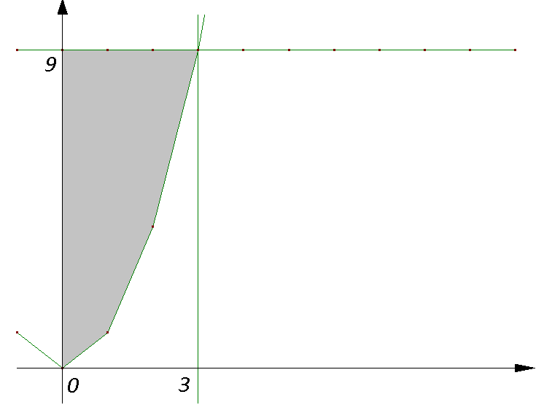

Graph 1

Change the order of integration using the graph.

Extend the boundaries of integration with respect to x.

Then

Use variable substitution method.

**Answer:**

1. on the domain

It is a proper integral.

Consider the graph of the integration domain on plane x0y (graph 2). Values of x are [-2;2]. Express the value of function y by x from equation , .

Then values of y are .

Solve the integrals separately.

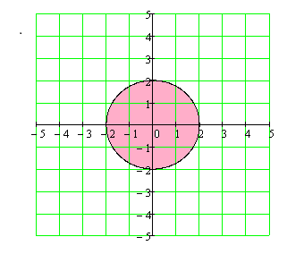

Graph 2

The first integral solve by the next change of variable

The second integral solve by the next change of variable

**Answer:**.

1. on the domain

Consider the graph of the integration domain on plane x0y (graph 3)

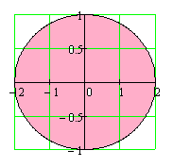

graph 3

Move on to the spherical coordinates, using the next formulas:

Jacobian of transformations , then

Use variable substitution method

**Answer:**

Exercise 4

1. Consider the curve on the plane given by the graph of the function in polar coordinates with . Find all the points where the tangent vector to the curve is parallel to the x-axis or to the y-axis.

Solution

We’ll first need the following derivative.

Then using the formula

find http://tutorial.math.lamar.edu/Classes/CalcII/PolarTangents_files/empty.gifhttp://tutorial.math.lamar.edu/Classes/CalcII/PolarTangents_files/empty.gif

Then tangent angle

when the tangent vector to the curve is parallel to the x-axis then solve the equation

in our case may be or and

Find the points ; then (), ().

when the tangent vector to the curve is parallel to the y-axis then solve the equation

in our case may be and

Find the points ; then (), ().

**Answer:** The points where the tangent vector to the curve is parallel to the x-axis: (), (); the points where the tangent vector to the curve is parallel to the y-axis (), ().

1. Find the length of the following parametric curve on the plane:

Solution

Use the formula

We’ll first need the following derivatives

Then

Using, that and trigonometric formulas of transformation products in the amount, get integral

Use formula

**Answer:** .

Exercise 5

1. Compute the line integral

of the vector field along the parametric curve with .

Solution

The line integral of F along C is

At fist find the vector field evaluated along the curve

And the derivative of the parameterization

Get the dot product taken care of

The line integral is then

**Answer:** .

1. Consider the vector field . Show that the vector field can be written as and find the function .

Then compute the line integral along the curve the parametric the curve with 0.

Solution

Find the function for this consider function , then

.

.

.

Take

The line integral of F along C is

At fist find the vector field evaluated along the curve

And the derivative of the parameterization

Get the dot product taken care of

The line integral is then

Integrate by parts

**Answer:** ; .

1. Compute the flux of the vector field

across the surface given by the portion of graph of the function cut off by the plane z=1 and oriented in the negative z direction.

Solution

The surface given by the portion of graph of the function cut off by the plane z=1 (graph 4)



The graph of the region S (graph 5)

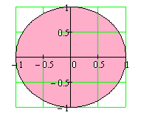

graph 5

graph 4

The flux of the vector field is

Find the vector normal to the surface oriented in the negative z direction, as

Then

The region S is the disk of radius 1 centered at the origin shown below. It is convenient to convert to polar coordinates, .

Then have

**Answer:**